Apply filters to SQL queries

Project description:
Used SQL filtering techniques to analyze login attempts and employee data to investigate potential security issues. Applied AND, OR, and NOT operators to retrieve specific records, such as failed logins after business hours, access from certain locations, and department-based employee information. These queries helped identify suspicious activity and support security monitoring and system management.

Retrieve after hours failed login attempts:
My team was tasked with investigating failed login attempts that occurred after business hours. I was responsible for retrieving this information from the login activity records to identify all unsuccessful login attempts made after 18:00.
The login_time column in the log_in_attempts table contains information on when login attempts were made. The success column indicates whether the login was successful, where 1 = TRUE (successful login) and 0 = FALSE (failed login).
SELECT *
FROM log_in_attempts
WHERE login_time > '18:00:00' AND success = 0;
This query selects all columns from the log_in_attempts table and applies a WHERE clause to filter the results. The condition login_time > '18:00:00' retrieves login attempts that occurred after business hours, while success = 0 ensures that only failed login attempts are returned. The AND operator combines both conditions to narrow the results to relevant security events.
Based on the query results shown in the screenshot below, the output returned 19 rows. This indicates that 19 employees attempted to log in after business hours but were unsuccessful. Identifying these failed after-hours login attempts helps detect potential unauthorized access attempts and supports proactive security monitoring.
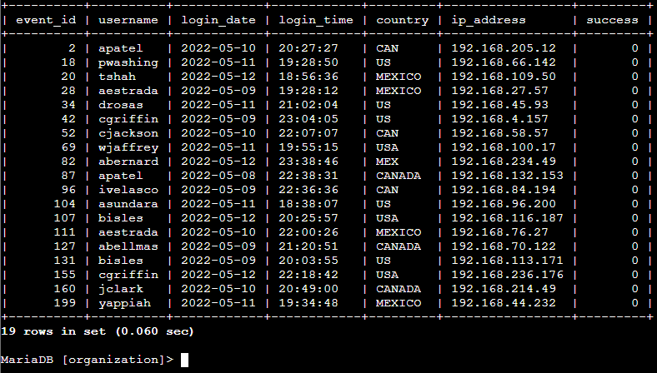

Retrieve login attempts on specific dates:
My team investigated a suspicious event that occurred on 2022-05-09, and I was tasked with retrieving all login attempts that occurred on that date and the day before, 2022-05-08. This provided additional context for the activity leading up to the event.
The login_date column in the log_in_attempts table contains information about the dates when login attempts were made.
SELECT *
FROM log_in_attempts
WHERE login_date = '2022-05-09' OR login_date = '2022-05-08';
This query selects all columns from the log_in_attempts table and applies a WHERE clause to filter the results based on specific dates. The condition retrieves records where the login_date is either 2022-05-09 or 2022-05-08. The OR operator allows the query to return results that match either of the specified dates, expanding the scope of the investigation.
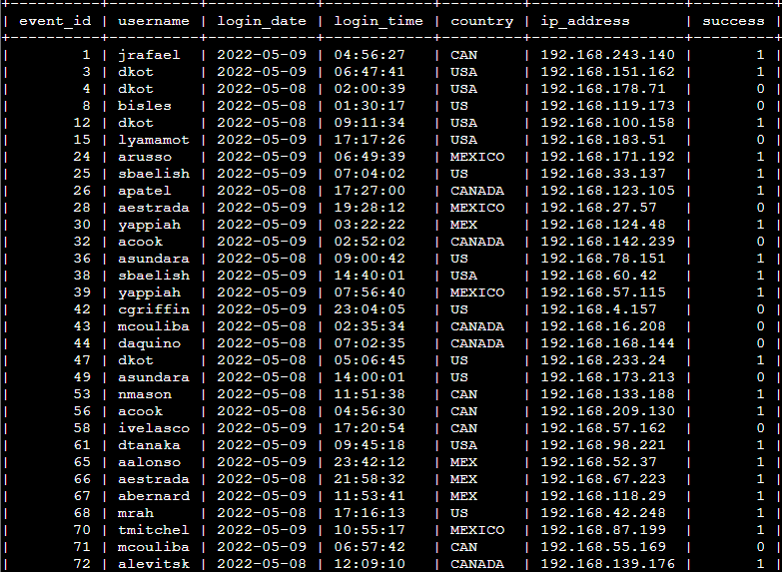
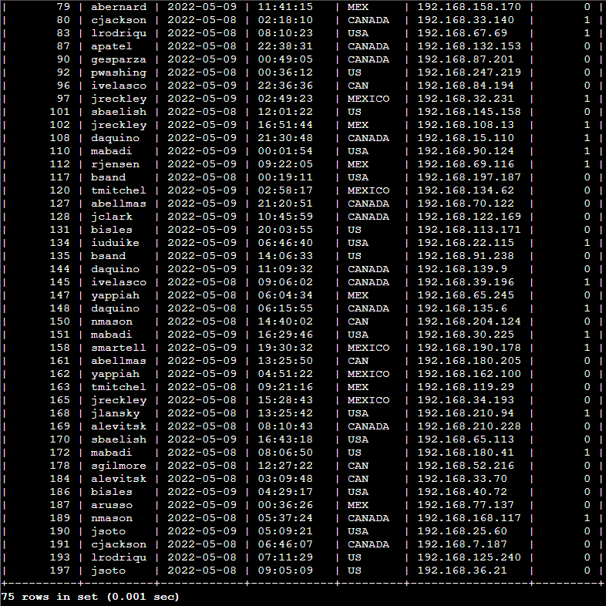
Based on the query results shown in the screenshots in my report, the output returned 75 rows. This indicates that 75 login attempts occurred across these two dates. Reviewing login activity during this timeframe helps identify unusual patterns and supports further investigation into the suspicious event.

Retrieve login attempts outside of Mexico:
My team investigated login activity originating from different countries, excluding Mexico. The country column contained entries labeled as both "MEX" and "MEXICO", so I was tasked with retrieving login attempts from all other countries while excluding these variations.
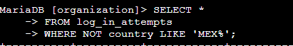
SELECT *
FROM log_in_attempts
WHERE NOT country LIKE 'MEX%';
This query selects all columns from the log_in_attempts table and applies a WHERE clause to filter the results based on the country column. The NOT operator combined with the LIKE clause excludes values that start with "MEX". The wildcard symbol % represents any sequence of characters, allowing the query to filter out both "MEX" and "MEXICO" entries. This ensures that only login attempts originating from countries outside of Mexico are returned.
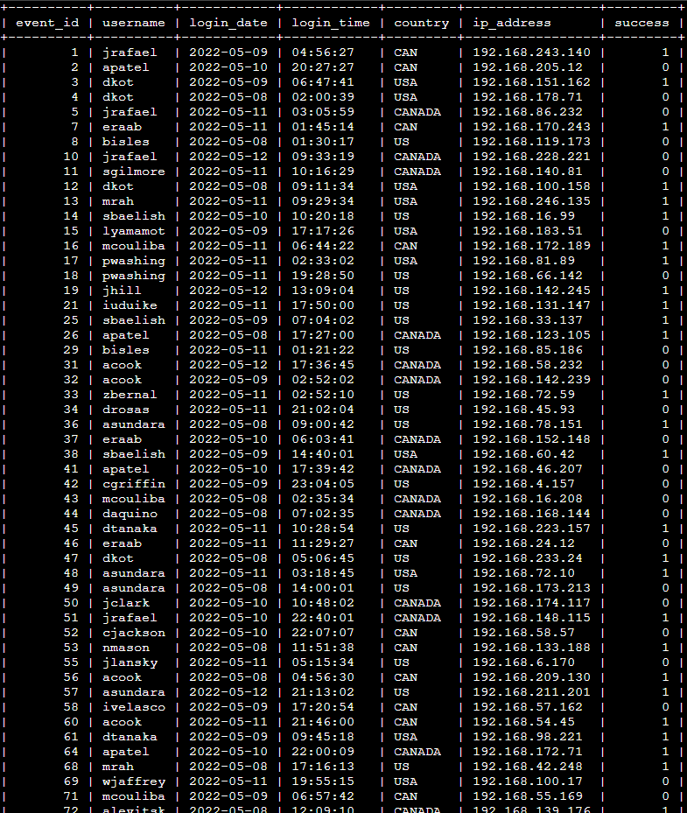
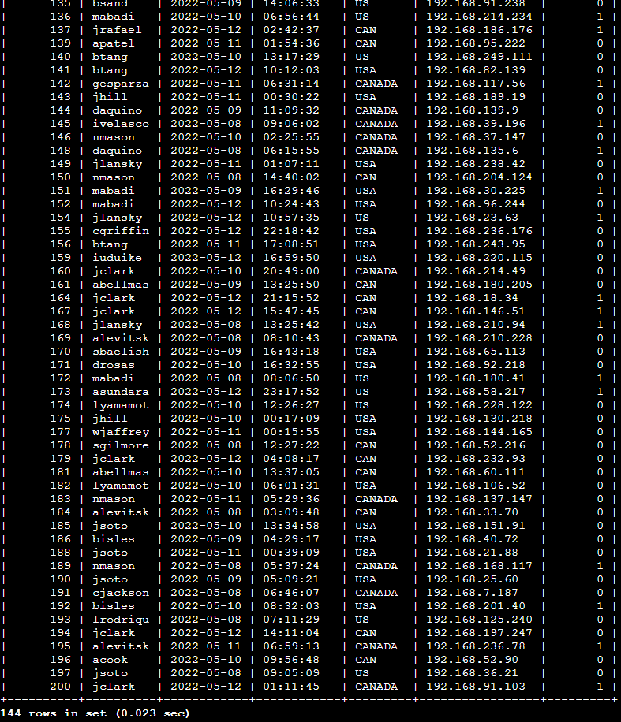
Based on the query results (shown in the screenshots in my report), the output returned 144 rows. This indicates that 144 login attempts originated from countries other than Mexico. Identifying login activity from external locations helps detect unusual access patterns and supports further security analysis.

Retrieve employees in Marketing:
My team investigated employees across different departments and office locations. The employees table includes the columns employee_id, device_id, username, department, and office. As part of updating employee machines, I was tasked with retrieving information about employees in the Marketing department whose offices are located in the East building.
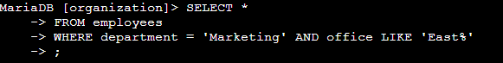
SELECT *
FROM employees
WHERE department = 'Marketing' AND office LIKE 'East%';
This query selects all columns from the employees table and applies a WHERE clause to filter the results. The condition department = 'Marketing' limits the output to employees within the Marketing department. The office LIKE 'East%' condition retrieves records where the office location begins with "East". The wildcard % allows for variations in office numbers, ensuring that all East building offices are included regardless of their specific room designation. The AND operator ensures that both conditions must be met.
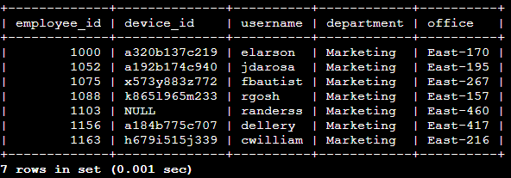
Based on the query results shown in the screenshot above, the output returned 7 rows. This indicates that seven employees belong to the Marketing department and are located in different offices within the East building. This information supports targeted system updates and helps ensure that only relevant employee machines are included in the task.

Retrieve employees in Finance or Sales:
My team needed to perform system updates on computers assigned to employees in the Finance and Sales departments. I was tasked with retrieving information about employees belonging to either of these departments to ensure the updates were applied to the correct systems.
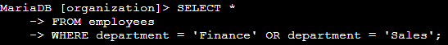
SELECT *
FROM employees
WHERE department = 'Finance' OR department = 'Sales';
This query selects all columns from the employees table and applies a WHERE clause to filter the results. The conditions check whether the department column is equal to Finance or Sales. The OR operator allows the query to return records that match either department, ensuring that employees from both groups are included in the output.
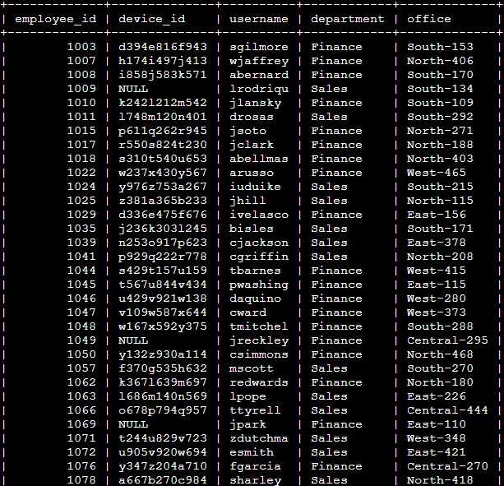
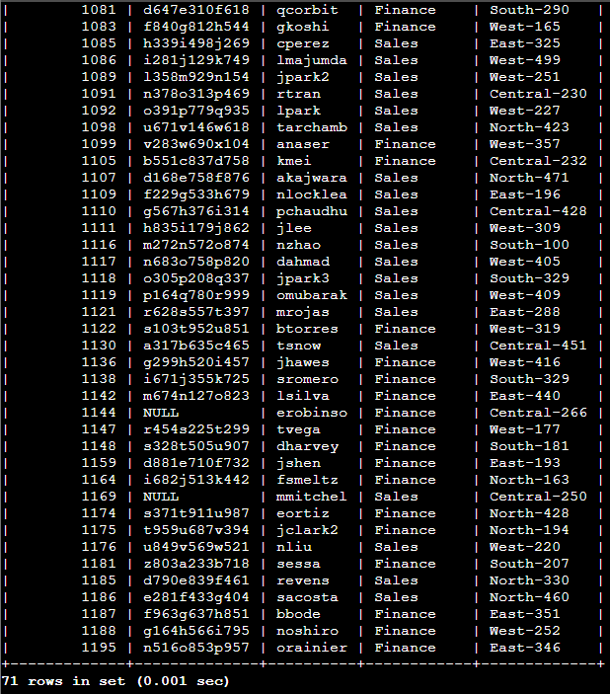
Based on the query results shown in the screenshot above, the output returned 71 rows. This indicates that 71 employees belong to either the Finance or Sales department. Identifying these employees helps ensure that system updates are applied efficiently and only to the intended departments, reducing unnecessary changes to other systems.

Retrieve all employees not in IT:
My team needed to perform an additional system update, and updates had already been completed for employees in the Information Technology (IT) department. I was tasked with retrieving information about employees who were not part of the IT department to ensure the remaining systems were included in the update.
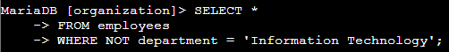
SELECT *
FROM employees
WHERE NOT department = 'Information Technology';
This query selects all columns from the employees table and applies a WHERE clause to filter the results. The NOT operator excludes records where the department column is equal to Information Technology, returning only employees outside of the IT department. This approach helps target remaining systems that still require updates.
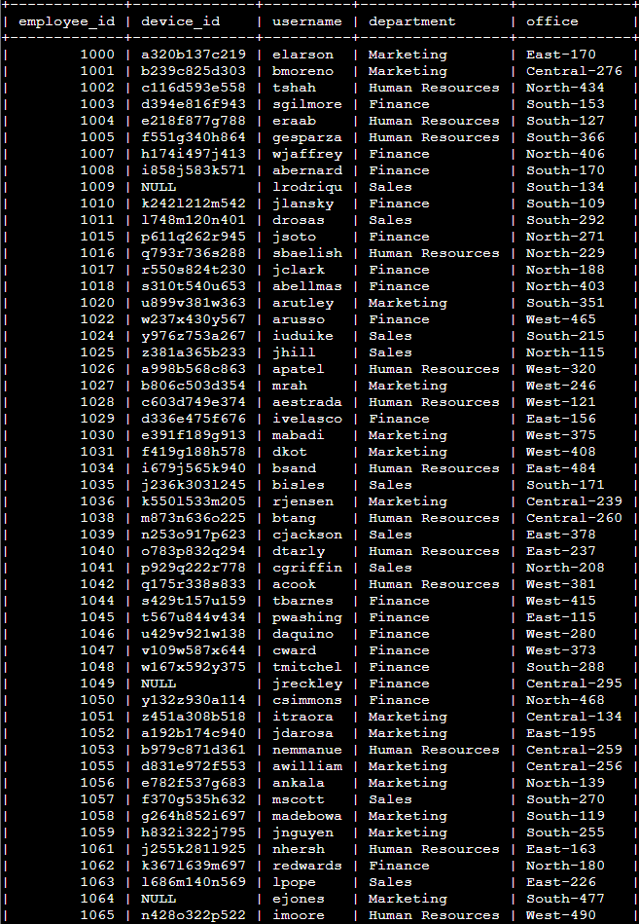
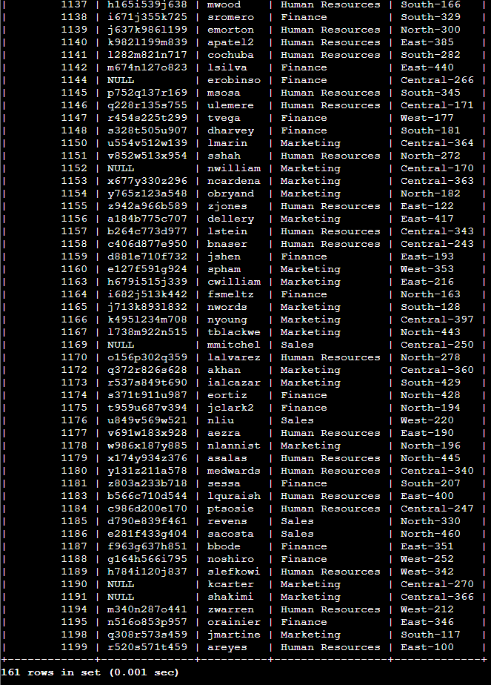
Based on the query results shown in the screenshot above, the output returned 161 rows. This indicates that 161 employees are not part of the Information Technology department. Identifying these employees ensures that system updates are applied to all relevant users while avoiding duplicate updates for IT systems that were already addressed.

Summary
In this activity, I used SQL filtering techniques to retrieve and analyze specific data related to login attempts and employee information. I applied logical operators such as AND, OR, and NOT, along with pattern matching using LIKE, to narrow down results based on multiple conditions. These queries helped identify failed login attempts after business hours, review activity on specific dates, analyze access from locations outside Mexico, and retrieve employee information by department and office location.
By filtering relevant records from the database, I was able to support security investigations, identify potential suspicious activity, and assist with targeted system updates. This activity strengthened my ability to write structured SQL queries and apply data filtering techniques to real-world cybersecurity scenarios.

